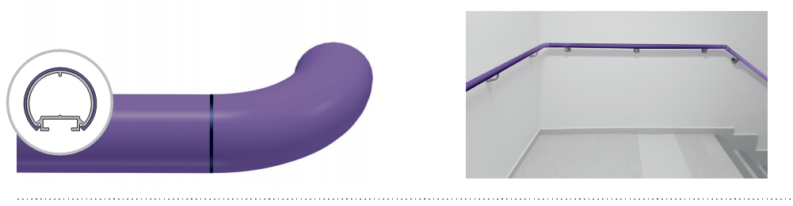



SPECIFICATION

ESCORT PVC SHEATHED
ROUND HANDRAIL – DIAMETER 40 MM

- Description: round handrail with antibacterial PVC sheath (Escort - PVC sheathed as manufactured by SPM) with a diameter of 40 mm and an overall projection and height of 80 mm. It consists of a 1.5 mm thick continuous aluminium profile covered by a 1.5 mm thick smooth and antibacterial PVC sheath achieving Bs2d0 fire rating with solid colour, and a matching closer underneath. A protective film is specified to minimise cleaning before acceptance. The section comprises a groove into which brackets and matching closer slide and lock. Wall fixing is by 40 mm deep satin silver anodised aluminium brackets with 2-point self-locking:curved and perforated (80 mm wide), curved and full (60 mm wide) or bugled (55 mm wide). Various smooth and antibacterial PVC accessories with solid colour (round or flat endcaps, external and internal 90° angle pieces or made-to-measure from 90 to 165°, wall returns), supplied with bactericidal joints, are available to finish the handrail assembly and are sleeved into the profile. All technical solutions are available to ensure continuity around corners (90° or made-to-measure), in staircases (slope link or 3-way “universal joint” rotation angle -Rapid’Angle® as manufactured by SPM-), across service ducts (quick removable assembly wedge or articulated link –Rapid’Access® as manufactured by SPM-) and around curved sections (pre-curved in the factory).
- Environment: no heavy metals and no substance potentially subjected to any REACH restriction are used in its manufacture, nor PBT/BPA. The calcium-zinc thermal stabilisation process is used. The emission level of volatile substance in inside air has been tested according to ISO 16000-6 and is very low (A+) according to the French regulation (23 March 2011 nr 2011-321 Decree and 19 April 2011 Order). 100% of the product are recyclable.
- Colour: selected by architects from manufacturer’s standard range.
- Installation method: upper edge of section 0.90 m max. above floor level. Fixes to 2-point self-locking aluminium brackets screwed to the wall at 1.20 m centres (0.80 m centres in heavy traffic corridors and on light partitions like plasterboard). Wall returns, endcaps and angles to be fixed with 2.5 mm Allen clamping screws.
